**Experiment No - 3**

**Aim :** Develop a native application that uses GPS location information

**Code:**

activity_main.xml

<?xml version="1.0" encoding="UTF-8"?>

<android.support.constraint.ConstraintLayout tools:context="**.MainActivity**" android:background="**@android:color/background_dark**" android:layout_height="**match_parent**" android:layout_width="**match_parent**" xmlns:tools="**http://schemas.android.com/tools**" xmlns:app="**http://schemas.android.com/apk/res-auto**" xmlns:android="**http://schemas.android.com/apk/res/android**">

<!--<ImageView-->

<!--android:id="@+id/imageView4"-->

<!--android:layout_width="wrap_content"-->

<!--android:layout_height="wrap_content"-->

<!--android:scaleType="centerCrop"-->

<!--app:layout_constraintBottom_toBottomOf="parent"-->

<!--app:layout_constraintEnd_toEndOf="parent"-->

<!--app:layout_constraintHorizontal_bias="1.0"-->

<!--app:layout_constraintStart_toStartOf="parent"-->

<!--app:layout_constraintTop_toTopOf="parent"-->

<!--app:layout_constraintVertical_bias="0.0"-->

<!--app:srcCompat="@drawable/mountain" />-->

<TextView android:layout_height="**wrap_content**" android:layout_width="**wrap_content**" tools:layout_editor_absoluteY="**2dp**" app:layout_constraintStart_toStartOf="**parent**" app:layout_constraintEnd_toEndOf="**parent**" android:textSize="**40sp**" android:textColor="**@android:color/background_light**" android:text="**HIKER APP**" android:layout_marginEnd="**8dp**" android:layout_marginStart="**8dp**" android:id="**@+id/textView3**"/>

<!--app:layout_constraintEnd_toStartOf="@+id/imageView4"-->

<!--app:layout_constraintHorizontal_bias="0.5"-->

<!--app:layout_constraintStart_toEndOf="@+id/imageView4"-->

<!--app:layout_constraintTop_toTopOf="@+id/imageView4" />-->

<TextView android:layout_height="**wrap_content**" android:layout_width="**wrap_content**" app:layout_constraintStart_toStartOf="**parent**" android:textSize="**24sp**" android:textColor="**@android:color/background_light**" android:text="**Latitude**" android:layout_marginStart="**30dp**" android:id="**@+id/latitudeView**" app:layout_constraintTop_toBottomOf="**@+id/textView3**" android:layout_marginTop="**25dp**"/><TextView android:layout_height="**wrap_content**" android:layout_width="**wrap_content**" app:layout_constraintStart_toStartOf="**parent**" android:textSize="**24sp**" android:textColor="**@android:color/background_light**" android:text="**Longitude**" android:layout_marginStart="**30dp**" android:id="**@+id/longitudeView**" app:layout_constraintTop_toBottomOf="**@+id/latitudeView**" android:layout_marginTop="**25dp**"/><TextView android:layout_height="**wrap_content**" android:layout_width="**wrap_content**" app:layout_constraintStart_toStartOf="**parent**" android:textSize="**24sp**" android:textColor="**@android:color/background_light**" android:text="**Accuracy**" android:layout_marginStart="**28dp**" android:id="**@+id/accuracyView**" app:layout_constraintTop_toBottomOf="**@+id/longitudeView**" android:layout_marginTop="**25dp**"/><TextView android:layout_height="**wrap_content**" android:layout_width="**wrap_content**" app:layout_constraintStart_toStartOf="**parent**" android:textSize="**24sp**" android:textColor="**@android:color/background_light**" android:text="**Altitude**" android:layout_marginStart="**28dp**" android:id="**@+id/altitudeView**" app:layout_constraintTop_toBottomOf="**@+id/accuracyView**" android:layout_marginTop="**25dp**"/><TextView android:layout_height="**wrap_content**" android:layout_width="**wrap_content**" app:layout_constraintStart_toStartOf="**parent**" android:textSize="**24sp**" android:textColor="**@android:color/background_light**" android:text="**Address\nSector 13, Nerul\nNavii Mumbai**" android:layout_marginStart="**28dp**" android:id="**@+id/addressView**" app:layout_constraintTop_toBottomOf="**@+id/altitudeView**" android:layout_marginTop="**20dp**"/></android.support.constraint.ConstraintLayout>-

AndroidManifest.xml

<?xml version="1.0" encoding="UTF-8"?>

-<manifest package="com.example.preeti.hikerapp" xmlns:android="http://schemas.android.com/apk/res/android">

<uses-permission android:name="android.permission.ACCESS_FINE_LOCATION"/>

<uses-permission android:name="android.permission.ACCESS_COARSE_LOCATION"/>

<uses-permission android:name="android.permission.ACCESS_NETWORK_STATE"/>

<uses-permission android:name="android.permission.INTERNET"/>

-<application android:theme="@style/Theme.AppCompat.NoActionBar" android:supportsRtl="true" android:roundIcon="@mipmap/ic_launcher_round" android:label="@string/app_name" android:icon="@mipmap/ic_launcher" android:allowBackup="true">

-<activity android:name=".MainActivity">

-<intent-filter>

<action android:name="android.intent.action.MAIN"/>

<category android:name="android.intent.category.LAUNCHER"/>

</intent-filter>

</activity>

</application>

</manifest>

MainActivity.java

import android.Manifest;

import android.content.Context;

import android.content.pm.PackageManager;

import android.location.Address;

import android.location.Geocoder;

import android.location.Location;

import android.location.LocationListener;

import android.location.LocationManager;

import android.support.annotation.NonNull;

import android.support.v4.app.ActivityCompat;

import android.support.v4.content.ContextCompat;

import android.support.v7.app.AppCompatActivity;

import android.os.Bundle;

import android.widget.TextView;

import android.widget.Toast;

import java.util.List;

import java.util.Locale;

public class MainActivity extends AppCompatActivity {

LocationManager locationManager;

LocationListener locationListener;

@Override

protected void onCreate(Bundle savedInstanceState) {

super.onCreate(savedInstanceState);

setContentView(R.layout.activity_main);

locationManager = (LocationManager) this.getSystemService(Context.LOCATION_SERVICE);

locationListener = new LocationListener() {

@Override

public void onLocationChanged(Location location) {

//Toast.makeText(MainActivity.this, location.toString(), Toast.LENGTH_LONG).show();

updateLocationDetails(location);

}

@Override

public void onStatusChanged(String provider, int status, Bundle extras) { }

@Override

public void onProviderEnabled(String provider) { }

@Override

public void onProviderDisabled(String provider) { }

};

if(ContextCompat.checkSelfPermission(this,Manifest.permission.ACCESS_FINE_LOCATION) != PackageManager.PERMISSION_GRANTED){

ActivityCompat.requestPermissions(this,new String[] {Manifest.permission.ACCESS_FINE_LOCATION},1);

}else{

// locationManager.requestLocationUpdates(LocationManager.GPS_PROVIDER,0,0,locationListener);

locationManager.requestLocationUpdates(LocationManager.NETWORK_PROVIDER,0,0,locationListener);

Location lastKnownLocation = locationManager.getLastKnownLocation(LocationManager.NETWORK_PROVIDER);

if(lastKnownLocation != null){

updateLocationDetails(lastKnownLocation);

}

}

}

@Override

public void onRequestPermissionsResult(int requestCode, @NonNull String[] permissions, @NonNull int[] grantResults) {

super.onRequestPermissionsResult(requestCode, permissions, grantResults);

if(grantResults.length > 0 && grantResults[0] == PackageManager.PERMISSION_GRANTED){

checkLocPermission();

}

}

public void checkLocPermission(){

if(ContextCompat.checkSelfPermission(this,Manifest.permission.ACCESS_FINE_LOCATION) == PackageManager.PERMISSION_GRANTED){

locationManager.requestLocationUpdates(LocationManager.GPS_PROVIDER,0,0,locationListener);

}

}

public void updateLocationDetails(Location location){

//Toast.makeText(this, location.toString(), Toast.LENGTH_SHORT).show();

TextView latitudeView = findViewById(R.id.latitudeView);

TextView longitudeView = findViewById(R.id.longitudeView);

TextView accuracyView = findViewById(R.id.accuracyView);

TextView altitudeView = findViewById(R.id.altitudeView);

TextView addressView = findViewById(R.id.addressView);

latitudeView.setText("Latitude : "+Double.toString(location.getLatitude()));

longitudeView.setText("Longitude : "+Double.toString(location.getLongitude()));

accuracyView.setText("Accuracy : "+Double.toString(location.getAccuracy()));

altitudeView.setText("Altitude : "+Double.toString(location.getAltitude()));

String address = "Could not locate address..";

Geocoder geocoder = new Geocoder(this, Locale.getDefault());

try {

List<Address> addressList = geocoder.getFromLocation(location.getLatitude(),location.getLongitude(),1);

if(addressList != null && addressList.size() > 0){

address = "Address :\n";

if(addressList.get(0).getThoroughfare() != null){

address += addressList.get(0).getThoroughfare() +"\n";

}

if(addressList.get(0).getLocality() != null){

address += addressList.get(0).getLocality() + "\n";

}

if(addressList.get(0).getPostalCode() != null){

address += addressList.get(0).getPostalCode() + "\n";

}

if(addressList.get(0).getCountryName() != null){

address += addressList.get(0).getCountryName();

}

}

}catch (Exception e){

e.printStackTrace();

}

addressView.setText(address);

}

}

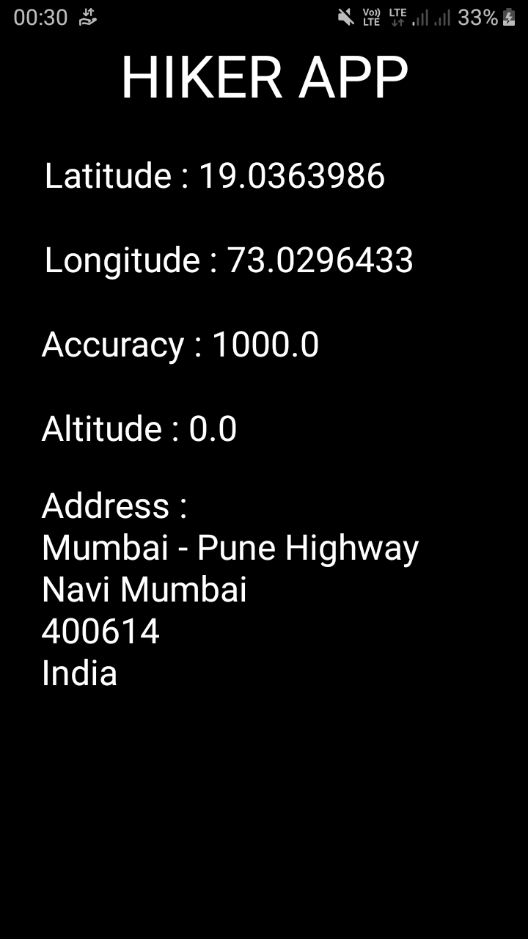

**Conclusion :**

In this experiment we show using GPS we can track location services and implemented the same successfully.